## Overview

In this activity, you will experiment with semantic elements and practice using documentation by implementing five unique elements.

## Instructions

### Part 1: Set Up Your Environment (3 min)

1. Open Chrome and start a new pen on CodePen.

*Tip:* Refer back to the [Hello, World! activity](https://docs.google.com/document/d/16nQVi5UwQCoiMVsggKeSUWVo840PnPEMetDFA4Mr5mg/edit) for detailed CodePen instructions.

1. Open a second Chrome window and navigate to Google. While coding, you will use this to search for documentation on each element.
2. Resize and reposition your Chrome windows so that you can see both:

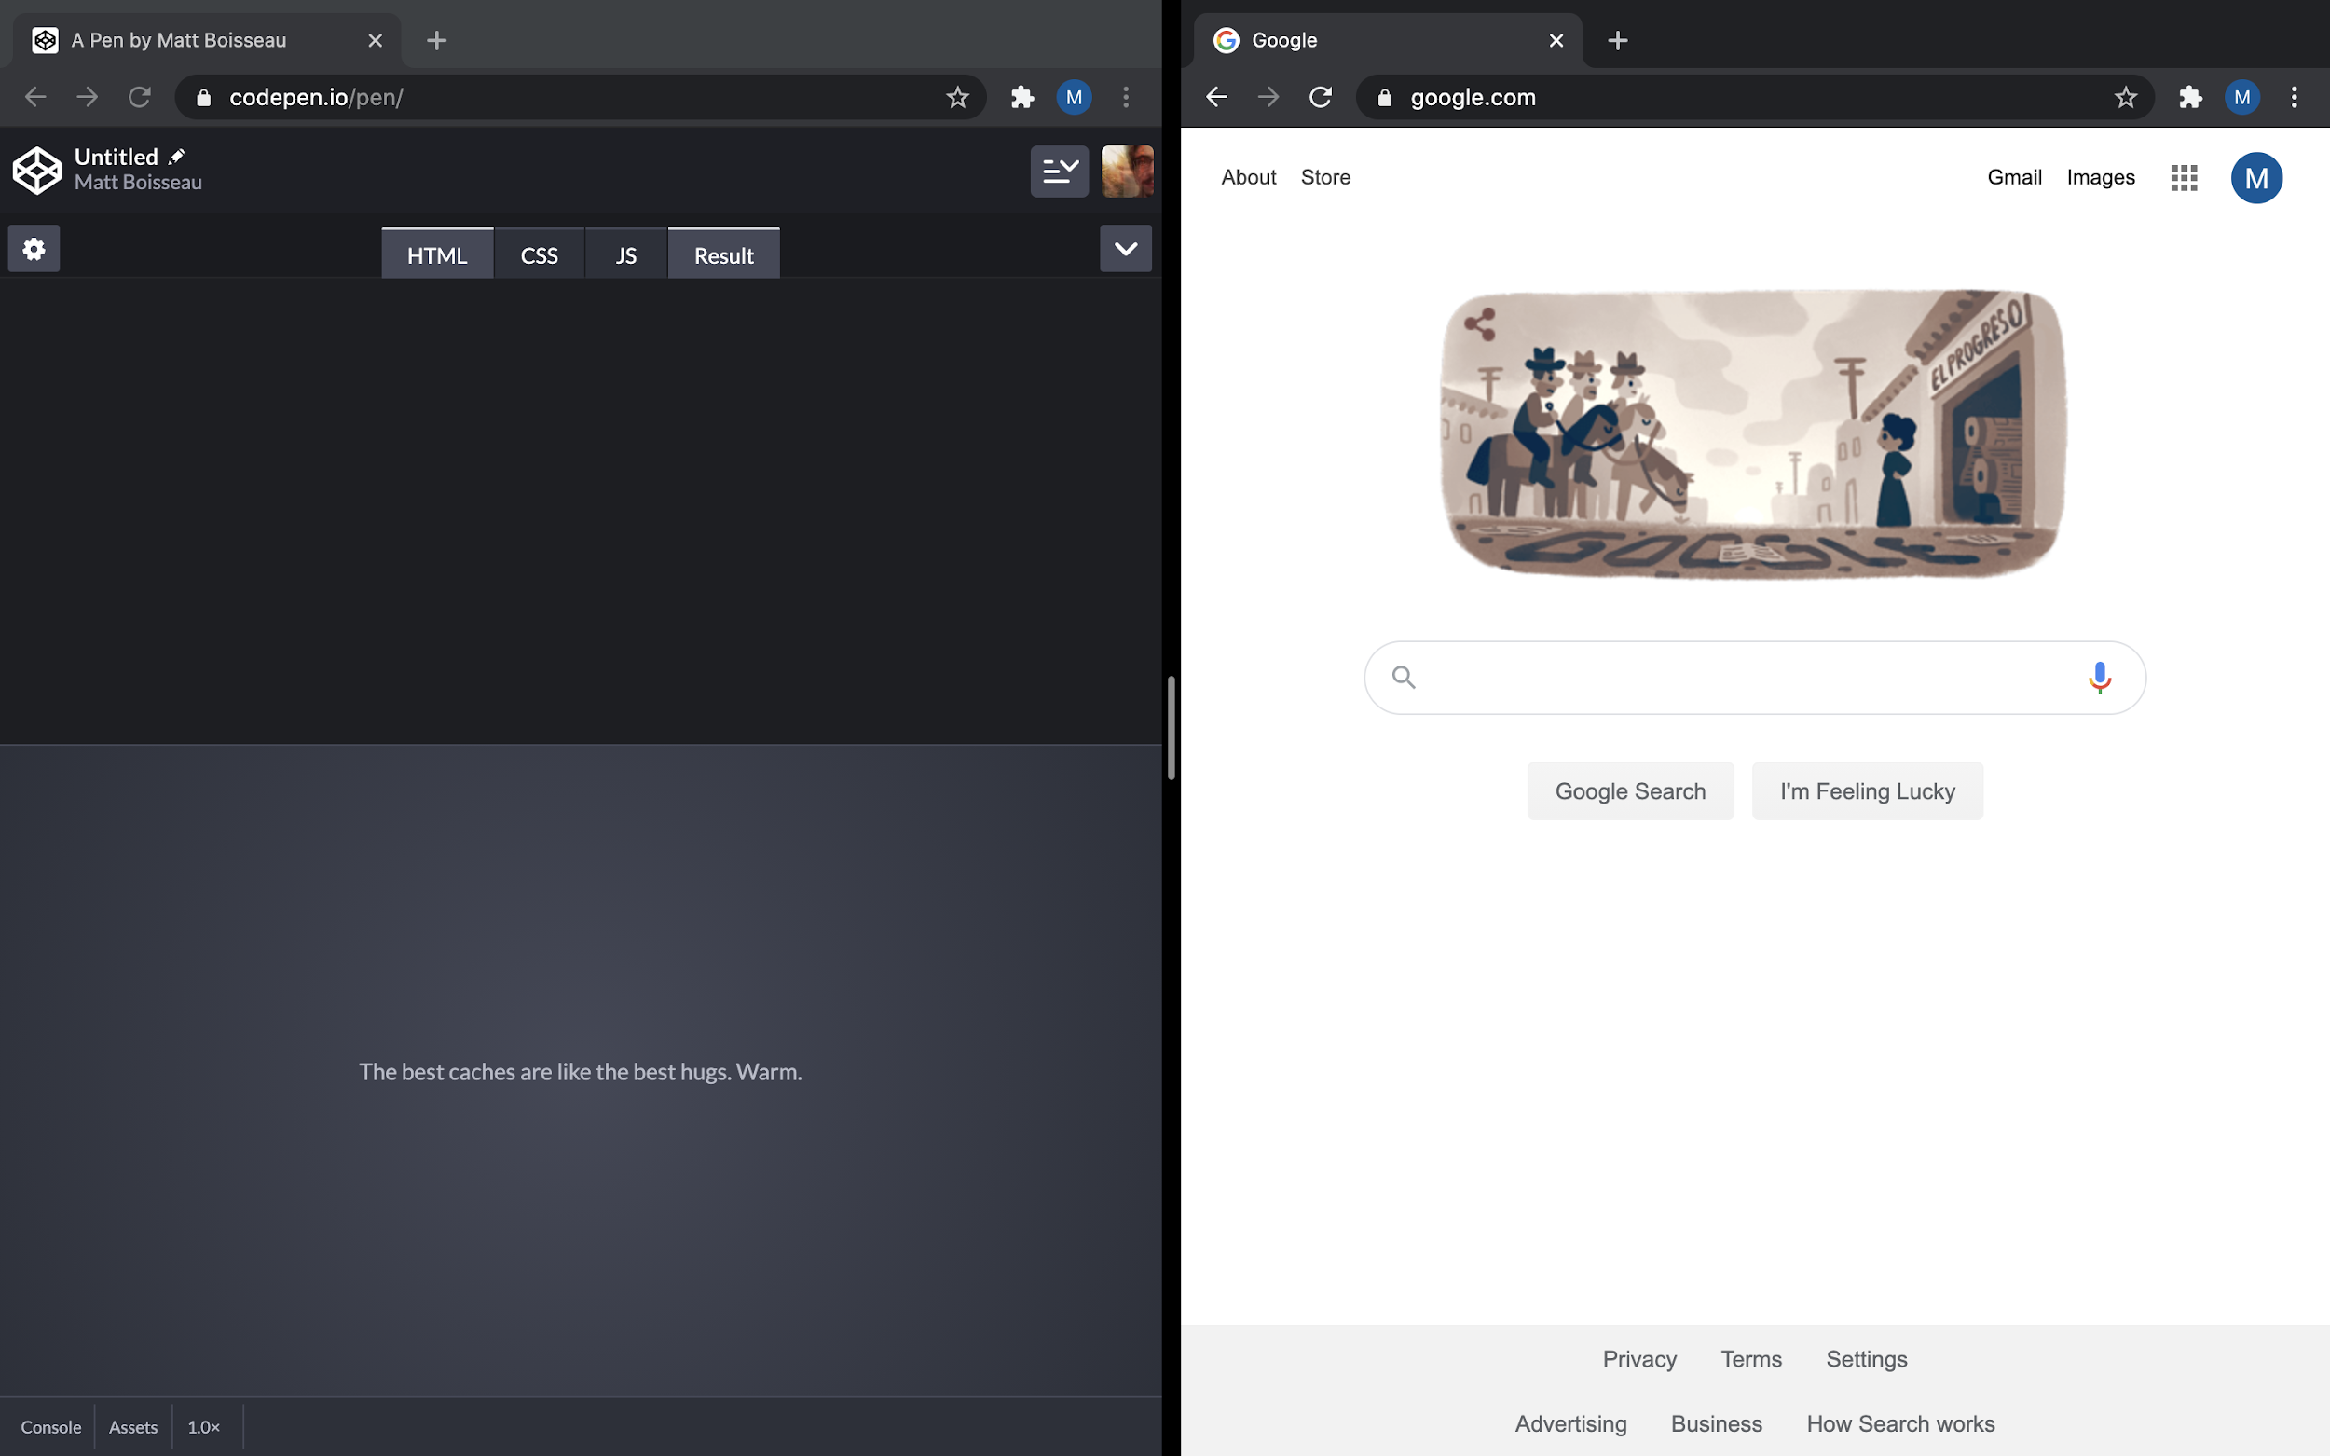

*Tip:* This side-by-side layout can be achieved quickly by using [Mac’s Split View](https://support.apple.com/en-us/HT204948) or [Windows’ Snap](https://support.microsoft.com/en-us/help/4027324/windows-10-snap-your-windows).

### Part 2: Add 3 Semantic Elements (5 min)

1. In the HTML panel, add three paragraph elements.
   1. Even if you feel confident creating paragraph elements, open the documentation for practice. To find the documentation, type w3c paragraph into Google.

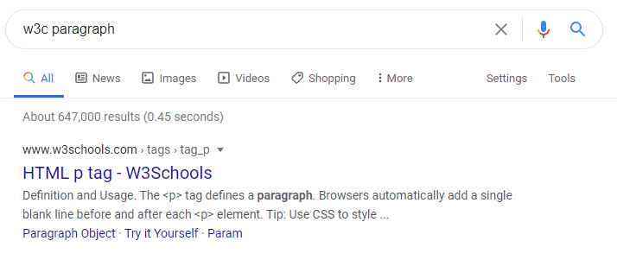

* 1. For the content of the first paragraph, write your name. For the other two, write anything you want.

1. Below your paragraphs, create an image element.
   1. Find the documentation for image elements in the same way as you did for paragraph elements.
   2. Provide alternate text that displays if the user can’t view the image.
   3. Provide a URL reference to any photo.

*Tip:* To copy the URL of a photo on the web, right click on it and select **Copy link address**.

* 1. Define a height and width for the image.

1. Below your image, create a multi-line text input.
   1. You don’t need to know the name of an element to find its documentation. Type w3c multi line text input into Google.
   2. The textarea element has many optional attributes. Use at least three attributes.
2. Check your work by comparing your code to [this solution on CodePen](https://codepen.io/2u-uxuxi-bootcamp/pen/gOmLENx).

### Part 3: Experiment With 2 Other Semantic Elements (5 min)

1. Use the documentation to add any two of these elements:
   1. figure
   2. input
   3. table
   4. nav
   5. hr

Alternatively, pick any two elements from [W3C’s list of every element](https://www.w3schools.com/tags/ref_byfunc.asp).

*Tip:* Don’t worry about getting these two exactly right. Make a note of anything you find difficult for the review phase.

### Part 4: Wrap Up and Share (2 min)

1. Give your pen a name by clicking on **Untitled Pen** in the top left. “Semantic Sandbox” is a good name for this code.

*Tip:* If you don’t see options like this, double-check that you’re logged in.

1. Select **Save** from the top-right menu to make your pen permanent.
2. Select **Share**, then **Copy Link** from the bottom-right menu.
3. Submit your code by pasting the link into Slack. Your link should look something like this: https://codepen.io/matt-boisseau/pen/bGpYqzg

## In the Real World

Reading documentation is an important part of programming in any language. When you transform a design into a functional website, you will need to know how to find the information necessary to create each element.

Remember that employers and clients don’t care if you have tags and attributes memorized; you just need to be resourceful enough to build the product.